1620 Assignment part 1

Contact App
For the first assignment you are going to create three responsive layouts for a contact application.
For part one you don’t need any JavaScript. You are going to create three separate responsive pages.
Due Date:

Instructions:
Create three html pages, based on the layouts below. Your layouts don't have to match the samples exactly but they should contain the described components.
All of your pages should use a single external stylesheet.

- Use only colors from the included color palette (link below) 1 point
- Include a Google font 1 points
- Insure that any images are not squished (they retain original aspect ratio or are “cropped” in CSS) 1 point
- check for accessibility (colors and contrast) 1 point
- Make use of CSS Flexbox to position elements 3 points
- Responsive design, incorporating media queries where needed. You only need to accommodate two screen sizes, desktop and mobile 3 points
- Git 3 points
  - Appropriate, meaningful Git commit messages. Make commits at appropriate intervals, not just one at the end
  - Make use of at least one remote feature branch. Push one of your branches to Github. You final work should all be in the Main branch
- readable code that follows style conventions 1 point
- semantically correct HTML 3 points
- Logical CSS, without redundant styles 3 points
Total 20 points

Examples of Desktop Layouts below.
Remember that your work has to be mobile friendly, so you also need to create a mobile view for each of the three pages
layouts:
layout one initial page shows all contacts, has create new contact button
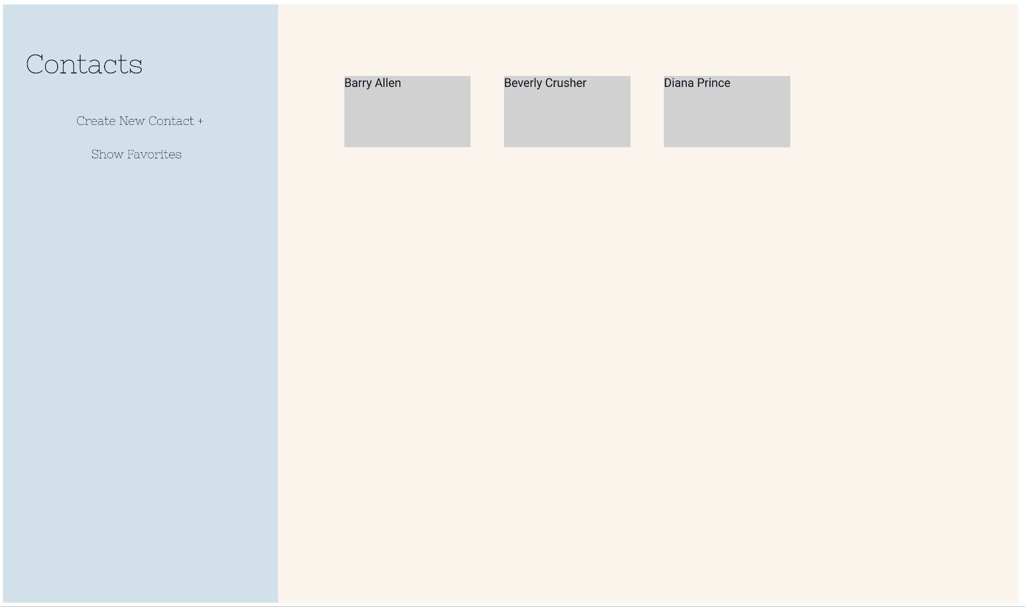
- Side nav
- Contact list grid each contact card could be an image or color from color palette

Second page with create new contact form
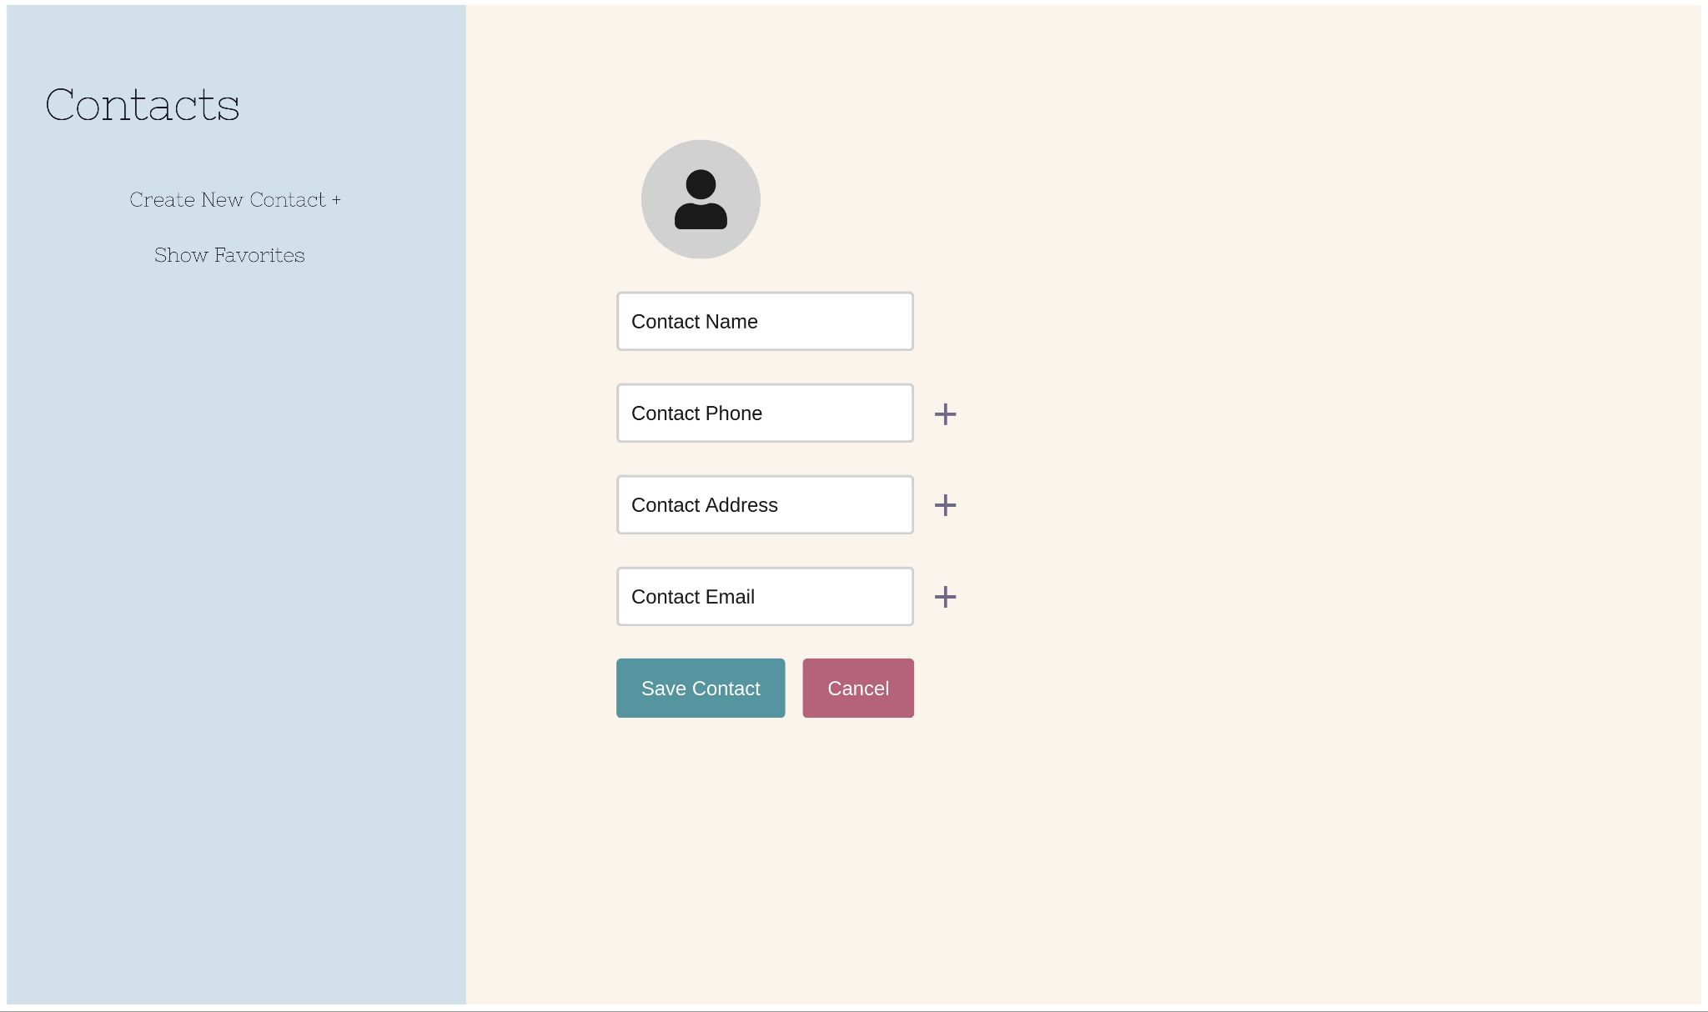
- Side nav
- Save Contact button and Cancel button
- New contact input fields including placeholder image

Third page displaying existing contact with Edit and Close buttons
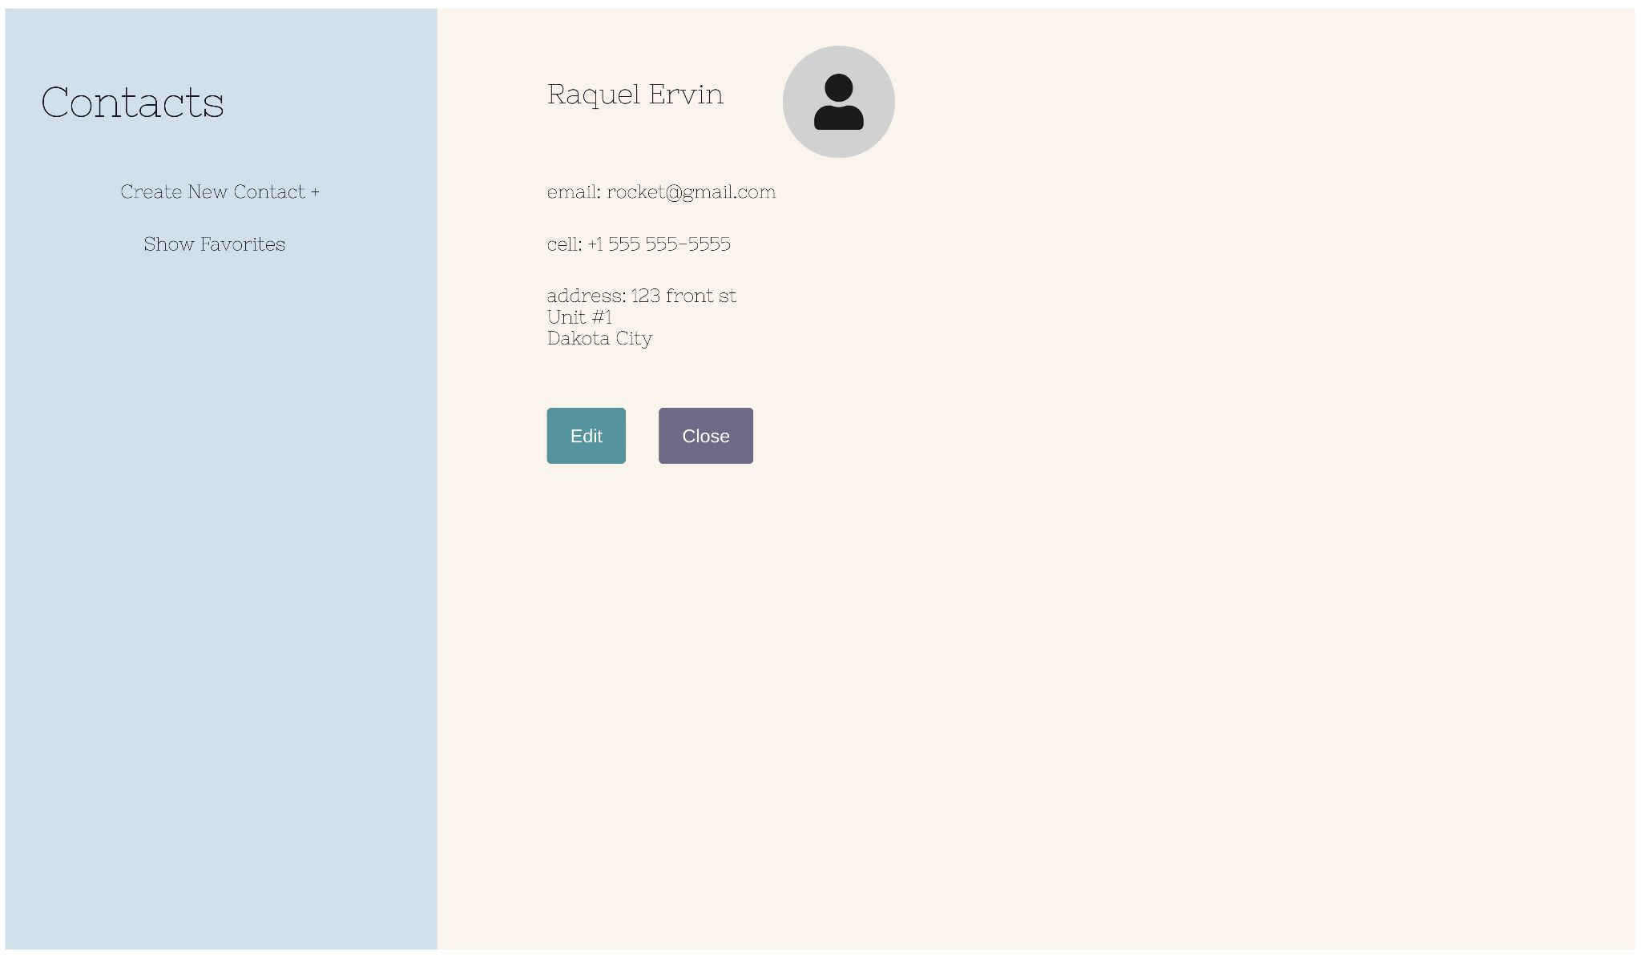
- Side nav
- Edit and Close buttons
- Contact Information
Including image of contact image must be a circle

Your color palette: 🎨
This is an existing color palette
https://rosepinetheme.com/palette.html
Submission Instructions:
Submit a public link to a GitHub repo containing your work.
Submit using the learning hub dropbox in assignments
Your repo should include the following:
- page1.html
- page2.html
- page3.html
- a CSS directory containing a style.css file

